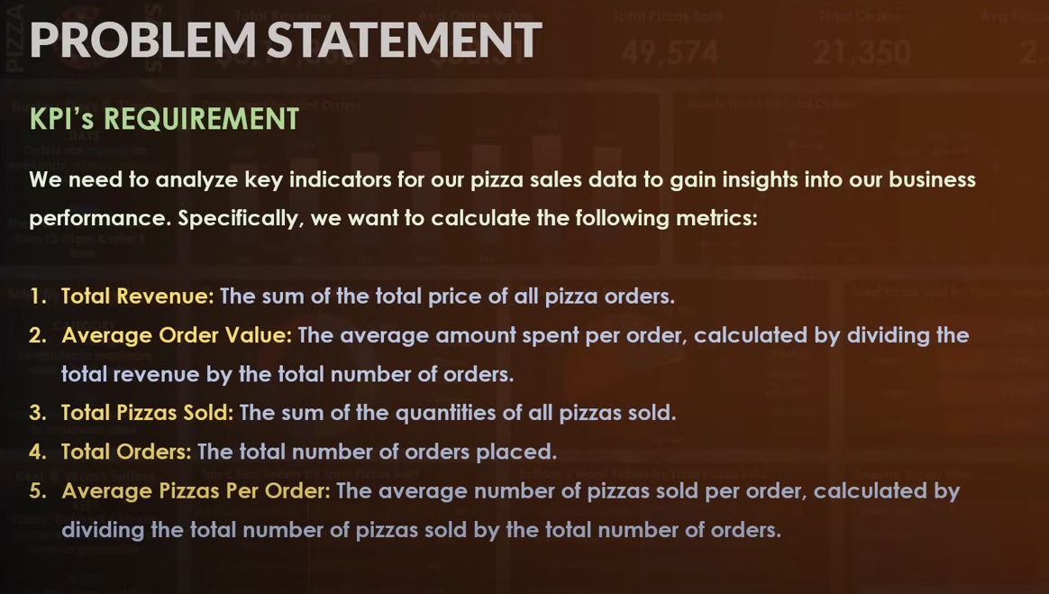

1--total revenue

select sum(total_price) as total_revenue from pizza_sales

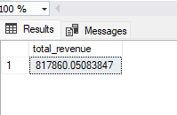

2--average order value

select (sum(total_price)/count(distinct order_id)) as average_order_value from pizza_sales

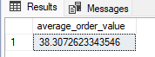

3--total prize sold

select sum(quantity) as total_pizzas_sold from pizza_sales

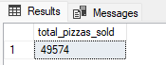

4--total order

select count(distinct order_id) as total_orders from pizza_sales



5--average pizza per order

select sum(quantity)/count(distinct order_id) as avg_pizza_per_order from pizza_sales

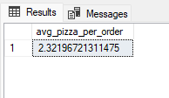

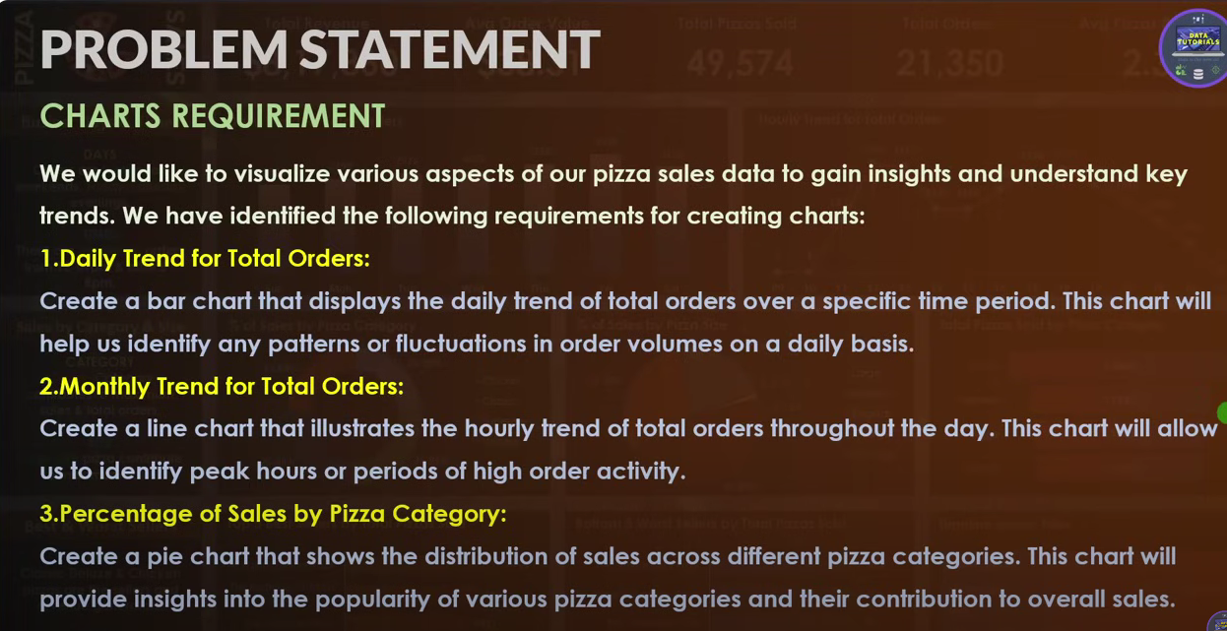

--PROBLEM STATEMENT

1--daily trent order

select DATENAME(dw,order_date)as order_day, count(distinct order_id) as total_orders

from pizza_sales

group by DATENAME(dw,order_date)

order by order_day asc

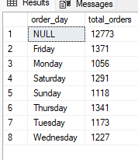

--2 MONTHLY TRENT FOR TOTAL ORDERS

select DATENAME(month,order_date) as order_month,count(distinct order_id) as total_orders

from pizza_sales

group by DATENAME(month,order_date)

order by order_month desc

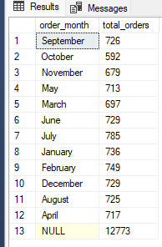

--3 % of sales by pizza category

select distinct pizza_category,

round(SUM(total_price)*100/(select sum(total_price) from pizza_sales),2) as percentage_of

from pizza_sales

group by pizza_category

order by percentage_of desc

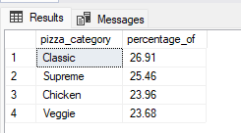

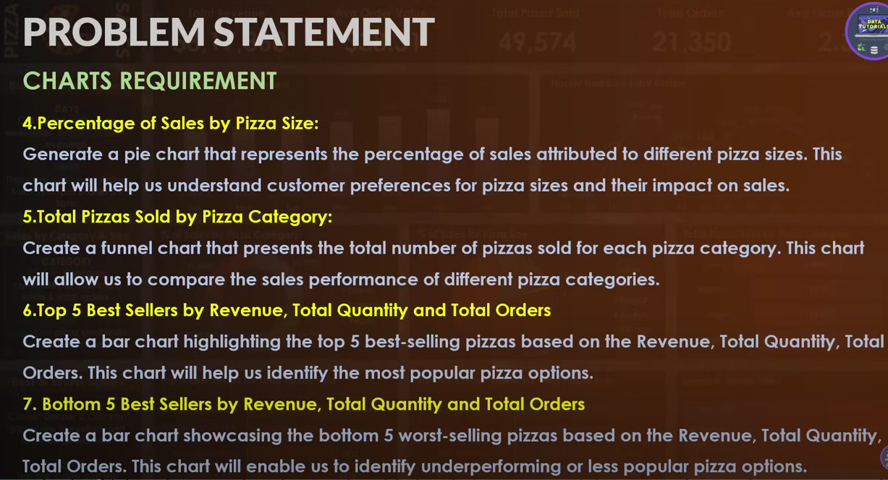

--4 % of sale by pizza size

select pizza_size,

round(SUM(total_price)*100/(select sum(total_price) from pizza_sales),2) as percentage_of_sale

from pizza_sales

group by pizza_size

order by percentage_of_sale desc

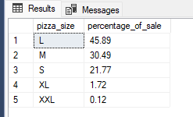

--5 total pizza sold by pizza category

select pizza_category,sum(quantity) as pizza_sold

from pizza_sales

group by pizza_category

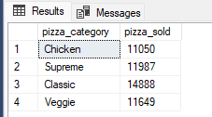

--6. top 5 best seller by revenue,total quantity and total orders

select top 5 pizza_name,sum(total_price) as revenue,

sum(quantity)as qunty,

count(distinct order_id) as orders

from pizza_sales

group by pizza_name

order by sum(total_price) desc

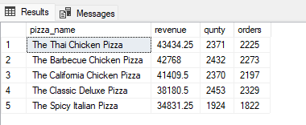

--7.Bottom 5 best seller by revenue,total quantity and total orders

select top 5 pizza_name,sum(total_price) as revenue,

sum(quantity)as qunty,

count(distinct order_id) as orders

from pizza_sales

group by pizza_name

order by sum(total_price) asc

